package crud_operations;

import com.mongodb.client.*;
import com.mongodb.client.model.Filters;
import com.mongodb.client.model.Updates;
import org.bson.Document;

public class mongodbcrud {

public static void main(String[] args) {

MongoClient mongoClient = MongoClients.create("mongodb://localhost:27017");

MongoDatabase database = mongoClient.getDatabase("CollegeDB");

MongoCollection<Document> collection =
database.getCollection("Students");

// CREATE
Document student = new Document("id", 101)
.append("name", "John")
.append("department", "CSE")
.append("cgpa", 8.7);

collection.insertOne(student);
System.out.println("Document Inserted Successfully");

// READ
System.out.println("\nStudent Records:");

FindIterable<Document> students = collection.find();

for (Document doc : students) {
System.out.println(doc.toJson());
}

// UPDATE
collection.updateOne(
Filters.eq("id", 101),
Updates.set("cgpa", 9.2)
);

System.out.println("\nDocument Updated Successfully");

// READ UPDATED RECORD
Document updatedStudent =
collection.find(Filters.eq("id", 101)).first();

System.out.println("\nUpdated Record:");
System.out.println(updatedStudent.toJson());

// DELETE
collection.deleteOne(Filters.eq("id", 101));

System.out.println("\nDocument Deleted Successfully");

mongoClient.close();
}
}

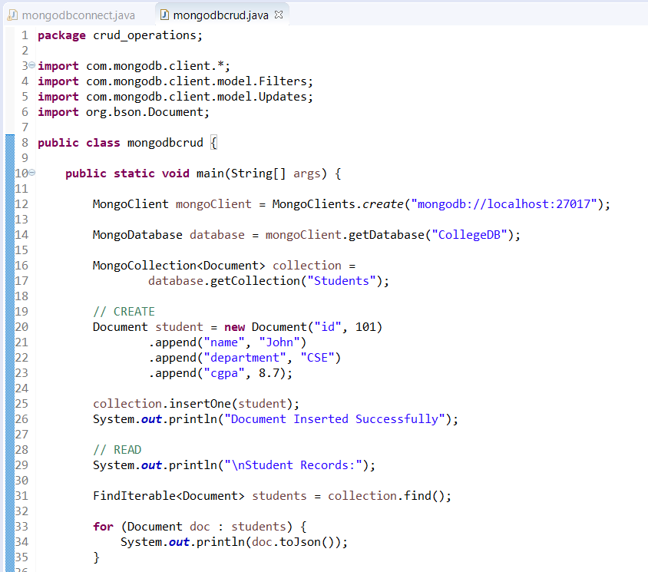
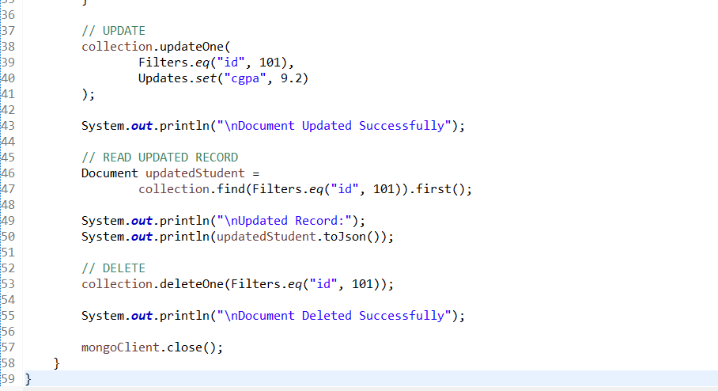
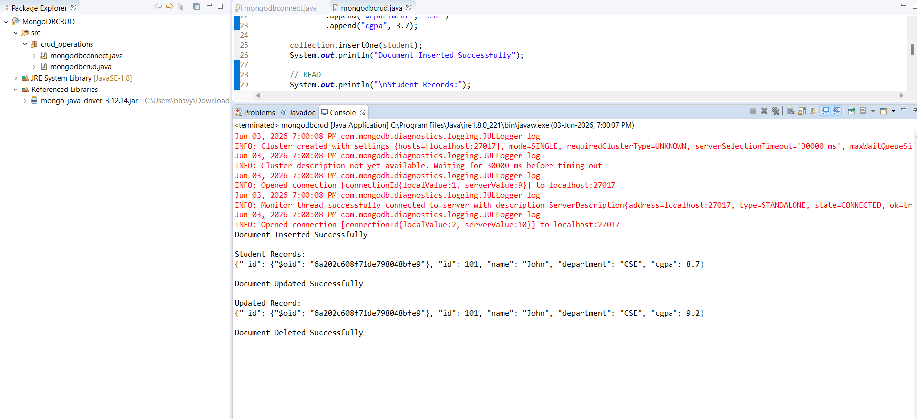
package crud_operations;

import com.mongodb.client.*;
import com.mongodb.client.model.Filters;
import com.mongodb.client.model.Updates;
import org.bson.Document;

import java.util.Arrays;

public class mongodbcrud {

public static void main(String[] args) {

MongoClient mongoClient = MongoClients.create("mongodb://localhost:27017");

MongoDatabase database = mongoClient.getDatabase("CollegeDB");
MongoCollection<Document> collection = database.getCollection("Students");

// ==========================
// CREATE MANY
// ==========================
Document s1 = new Document("id", 101)
.append("name", "John")
.append("department", "CSE")
.append("cgpa", 8.7);

Document s2 = new Document("id", 102)
.append("name", "Rahul")
.append("department", "CSE")
.append("cgpa", 8.2);

Document s3 = new Document("id", 103)
.append("name", "Aman")
.append("department", "CSE")
.append("cgpa", 7.9);

collection.insertMany(Arrays.asList(s1, s2, s3));

System.out.println("Multiple Documents Inserted Successfully");

// ==========================
// READ MANY
// ==========================
System.out.println("\nStudent Records:");

FindIterable<Document> students = collection.find();

for (Document doc : students) {
System.out.println(doc.toJson());
}

// ==========================
// UPDATE MANY
// ==========================
collection.updateMany(
Filters.eq("department", "CSE"),
Updates.set("cgpa", 9.0)
);

System.out.println("\nMultiple Documents Updated Successfully");

// ==========================
// READ UPDATED RECORDS
// ==========================
System.out.println("\nUpdated Records:");

FindIterable<Document> updatedStudents =
collection.find(Filters.eq("department", "CSE"));

for (Document doc : updatedStudents) {
System.out.println(doc.toJson());
}

// ==========================
// DELETE MANY
// ==========================
collection.deleteMany(
Filters.eq("department", "CSE")
);

System.out.println("\nMultiple Documents Deleted Successfully");

mongoClient.close();
}
}

